Korean Behavior Services Orientation Online
- To take training online, follow this link to the Parent Learning Center. Select the register button if you are a new user, or login using your e-mail address and password if you are a returning user. To register, click on the Register button to create a free account. You must have your child’s UCI number and an email address to complete the registration process. If you do not have an email address, you may enter your child’s UCI number in the email fields. If you need assistance or do not have the UCI number, contact your service coordinator to assist you. If you need assistance, e-mail training@lanterman.org or call 213.252.4976.
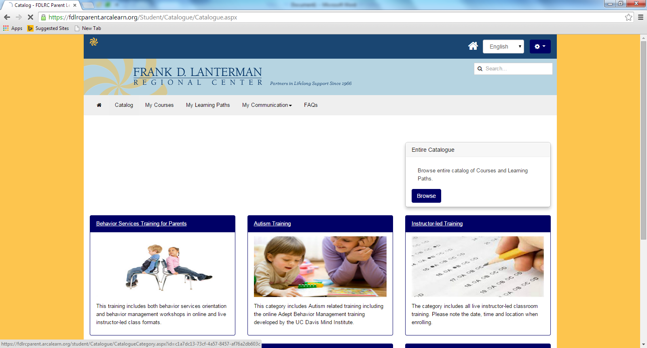
- Once logged in, select the Catolog Tab, Then Behavior Services Training.
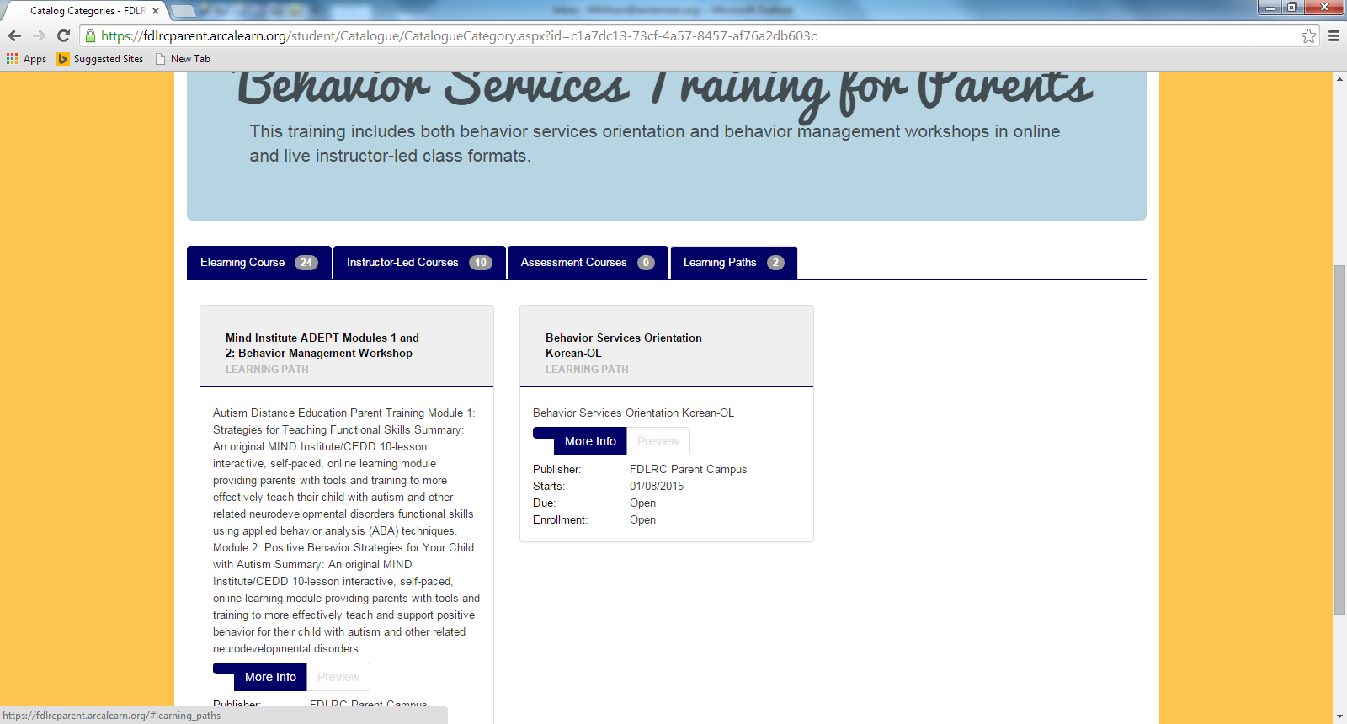
- Next select Learning Path and then Behavioral Services Orientation – Korean. Once you are enrolled, you may start the training. If while you are taking the training you need to stop and return later, you will find your training under the My Learning Paths Tab.
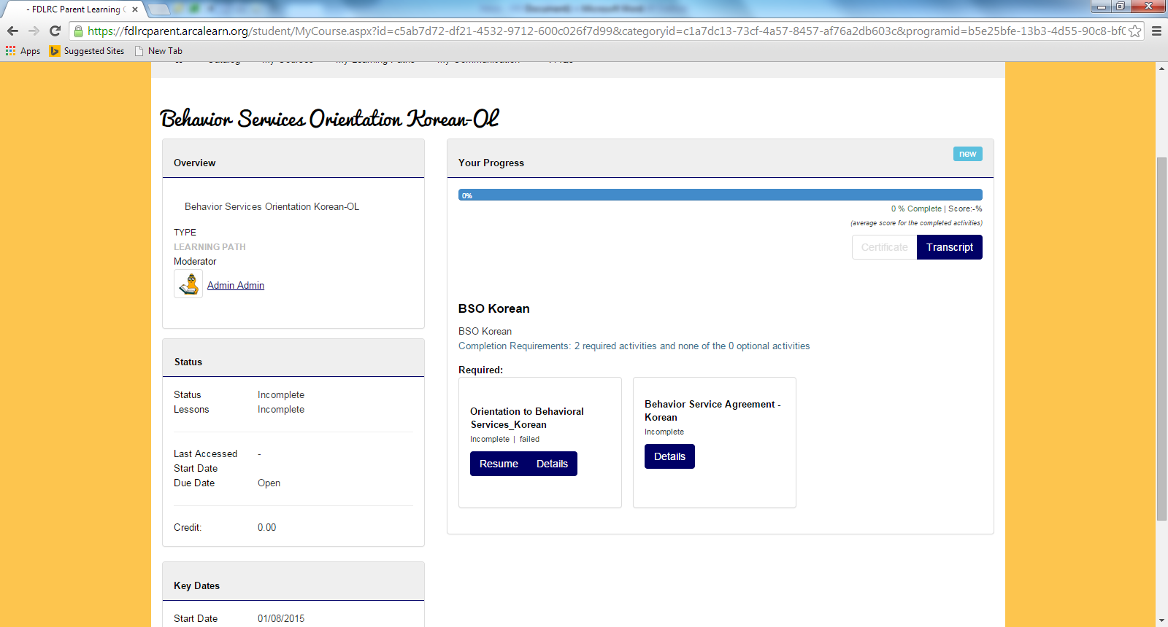
- If there is an activity such as a document to read or form for you to complete or sign, you will not obtain a completed status in the course until you complete the activity. To complete an activity, select the Activity button, the activity document link and follow these instructions for completing and submitting the document. Click on the document link, to download the document. Complete the form, save to your desktop, and chose the completed document file using the Choose File button. Once chosen, select the Submit button to upload the document.
