November 17, 202

Request for proposals

Development of New Resources

Enhanced community integration (Social Recreation) Grant

ANNOUNCEMENT

The Frank D. Lanterman Regional Center (FDLRC) is seeking proposals from community entities to enhance and develop integrated and inclusive social and recreational programs for families, children and adolescents with developmental disabilities in underserved communities. The service shall meet the following goals:

- Improve accessibility of integrated social and recreational programs that are person centered and culturally and linguistically responsive to the beliefs, values and choices of children and adolescents with intellectual and developmental disabilities.
• Utilize and leverage existing community resources to enhance and develop integrated and inclusive social and recreational programs that are safe and age appropriate; and
• Increase the number of RC vendored providers that offer integrated and inclusive social and recreational services to people with intellectual and developmental disabilities.

If you are interested in developing these services, please complete a proposal in accordance with the submission instructions below. The next sections of the RFP briefly describe the service need, service specifications and procedures for vendorization.

Deadline for Submission

Proposals must be received by the Regional Center by 4:00 PM on Wednesday, December 28, 2022. Applications that are incomplete, fail to comply with instructions or do not meet the basic requirements will be disqualified. No proposals will be returned.

Christian Irigoyen
Resource Developer
Frank D. Lanterman Regional Center
cirigoyen@lanterman.org

This RFP does not commit Lanterman Regional Center to procure or vendor the proposed service. Vendorization does not guarantee client referrals or purchases of service.

PROJECT SUMMARY
Community entities will submit grant proposals to the regional centers (RCs), which the RCs will score and prioritize according to the grant goals, grant priorities and the needs of the regional center’s catchment area. RCs will recommend grant proposals for approval and the California Department of Developmental Services (DDS) will determine which grant proposals will be approved. RCs will contract with grantees for the 8-month project term. Grantees will report their progress on meeting standard outcome measures to RCs on a quarterly basis on a form provided by DDS. RCs will review and approve quarterly reports. Approved progress reports will be submitted to DDS. DDS will review progress reports and provide feedback to RCs as needed. To be considered for approval, proposals must meet criteria within these guidelines; reflect collaborative efforts between RCs and applicants; and support children and adolescents who are:

- Three (3) to twenty-one (21) years of age
- Determined eligible for RC services including provisional eligibility for Lanterman Act programs
- From diverse monolingual and multilingual communities who face barriers to accessing RC services

Proposals supporting children and adolescents with hearing loss and from rural areas will be strongly considered.

Geographic Location

The Frank D. Lanterman Regional Center provides services to individuals in the cities of Burbank, Glendale, La Cañada and Pasadena, as well as the Hollywood, mid-Wilshire and Downtown areas of Los Angeles. Provider is strongly encouraged to serve all cities.

Social Rec. Grant Priorities

DDS developed the following grant priorities with input from families, self-advocates, the Association of Regional Center Agencies, community-based organizations (CBOs) and local parks and recreation entities. Proposals that address the following priorities will be strongly considered:

- Create, re-establish and/or enhance existing programs that are inclusive of children and adolescents with I/DD by applying evidence-based, best or emerging practices
- Support development of friendships between children and adolescents through integrated and inclusive programs and activities
- Hire and train staff to ensure the provision of adequate support for children and adolescents with complex needs (i.e., physical, and behavioral)
- Support communities with cultural awareness and sensitivity by enhancing language access and cultural competence within social and recreational programs and activities
- Develop and vendor inclusive social and recreational programs that apply person-centered and family-centered practices.

Grant Applicants

Grant applicants may include, but are not limited to:

- Community Based Organizations (CBOs)
- Religious organizations (e.g., churches, synagogues)
- Private recreational businesses or studios (e.g., karate schools, ballet studios, art studios)
- YMCAs, Boys & Girls Clubs, Girl Scouts, Boy Scouts
- County and city parks and recreation entities
- Public and private camps
- After-school programs

Grant Applicant Proposal Submission Requirements

To apply for a social rec grant, each grant applicant must submit a proposal to the RC’s designee, which are listed in the Regional Center Directory (Appendix E). Each proposal will include one or more project type. DDS has developed standard outcome measures for all grant project types. Applicants will be required to identify goals for each standard outcome measure applicable to the grant proposal and report progress towards meeting goals in subsequent quarterly reports, if the grant proposal is approved. RCs will confirm that the goals for the standard outcome measures are appropriate for the scope of the proposal during the application review process. Additional information on this process is provided in Project Types and Standard Outcome Measures (Appendix C).

Each proposal must include the following items:

- Completed Letter of Intent (Appendix A)
- Grant Budget Form (Appendix B)
- One or more project type (Appendix C)

Criteria for Funds to be Released to Grantee

The following criteria must be met to release funds to the grantee:

1. An initial payment of 30 percent of the grant amount will be paid after the grant project contract is executed and the grantee submits an invoice to the RC.
2. Subsequent payments of 30 percent of the grant amount will be made after the following conditions are met:
- The grantee reports the expenditure of at least 60 percent of the funds paid to date or requests an additional payment to ensure the success of the grant project.
- The RC determines the grantee is meeting deliverables in accordance with the grant project
- RC determines the expenses in the most recent progress report are appropriate and in accordance with the approved budget
- RC approves the most recent progress report
- RC approves the invoice that is submitted with the progress report
- 90 percent of the grant amount have not been paid.
3. A final payment of 10 percent of the grant amount will be made after all of the following conditions have been met:
- The grantee submits its final report within 7 days of completion of the project
- The grantee provides a final accounting and reconciliation of funds received and actual grant expenditures and submits its accounting and reconciliation to the RC
- The RC has reconciled grantee’s invoices against its expenses
- The RC has made a determination that the grantee has satisfactorily completed all the terms and conditions required by the contract, including providing additional information requested by the RC.

Estimated Service Duration
All awarded projects must begin on or before April 1, 2023. The grant project completion deadline is December 1, 2023.

Submission Information
Proposals must be emailed to cirigoyen@lanterman.org by December 28, 2022. Submissions that are late, mailed, or faxed will not be accepted.

Contact Person
Questions pertaining to submission instructions may be directed to:
Christian Irigoyen, Resource Developer, 213-252-6012
Pablo Ibañez, Director Community Services, 213-252-4928

Timeline

 | December 28, 2022 | Deadline for receipt of proposals
 | January 13, 2023 | Evaluation of proposals by Selection Committee
 | January 31, 2023 | FDLRC submits proposals to DDS
 | February 28, 2023 | DDS informs FDLRC of awarded grant projects and final RC funding allocation amounts are confirmed
 | March 31, 2023 | Grant contracts due to DDS
 | April 1, 2023 | All awarded projects must begin
 | December 1, 2023 | Grant project completion deadline – all reports due to FDLRC
 | December 31, 2023 | Final RC payments to grantees
 | January 31, 2024 | Final RC billing to DDS

Proposal Requirements and Submission Information (Ctrl + Click to Follow Link)
- Appendix A - Letter of Intent Application
- Appendix B - Grant Budget Form
- Appendix C - Project Types and Standard Outcome Measures
- Appendix D - Definition of Key Terms
- Appendix E - Regional Center Directory

Appendix A- Link to Fill Out Application: Letter of Intent Application
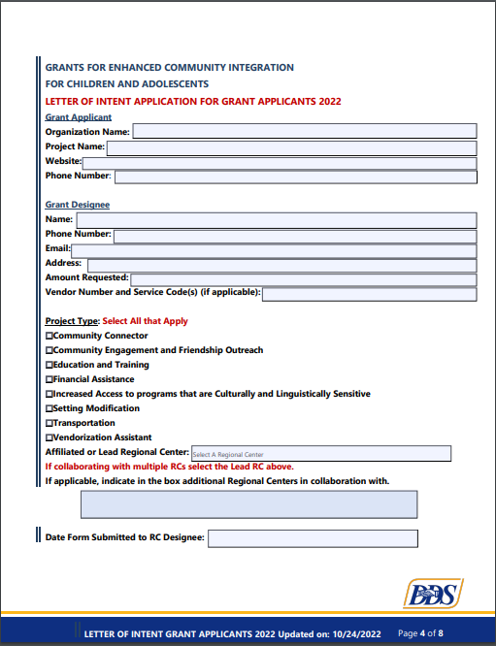
Appendix A (Cont.) 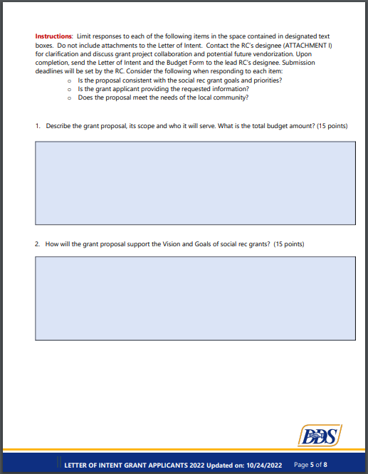Appendix A (Cont.) 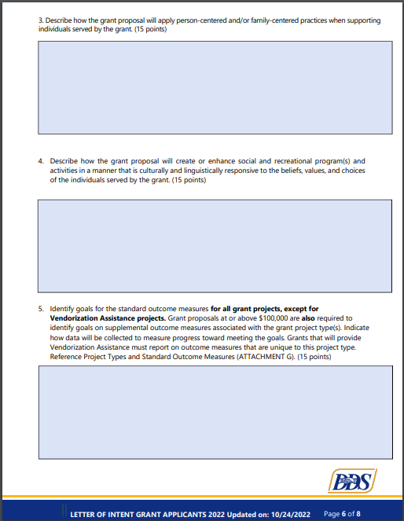Appendix A (Cont.) 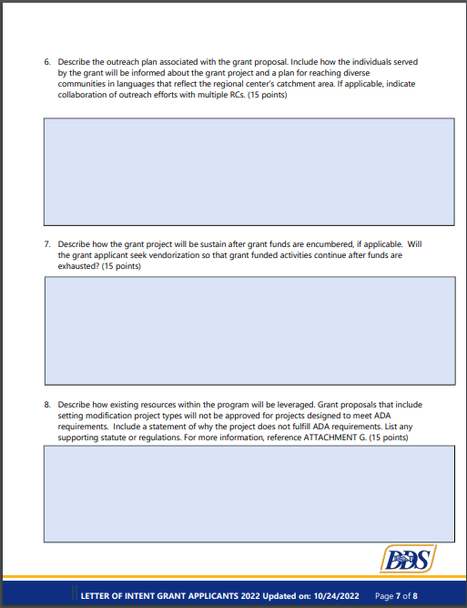Appendix B-Link to Fill Out Budget Form: Grant Budget Form
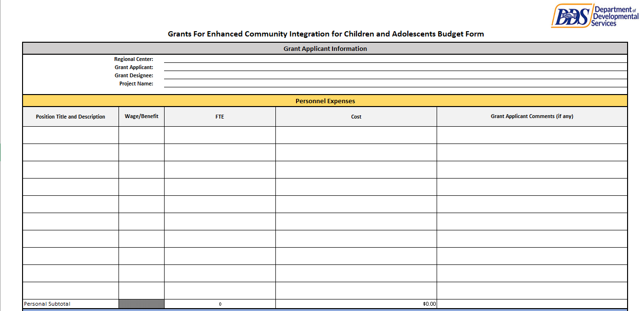
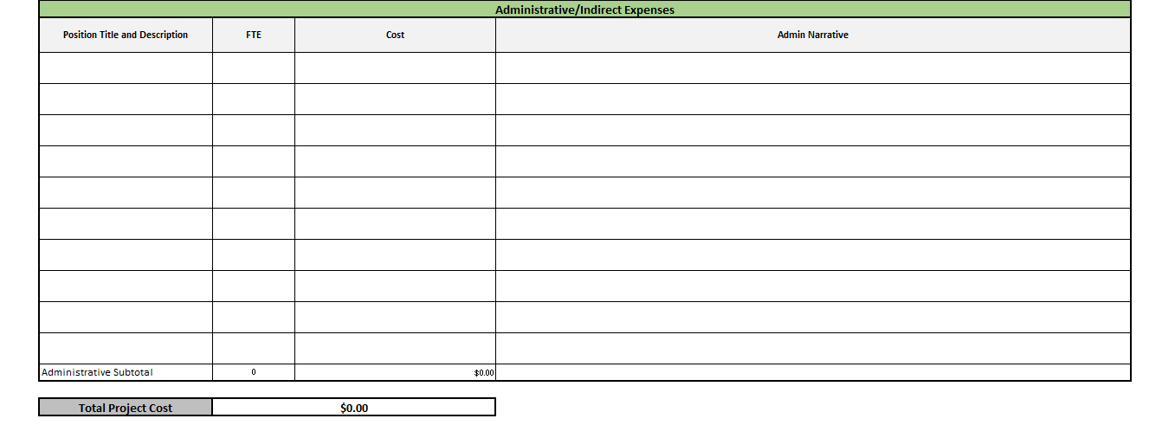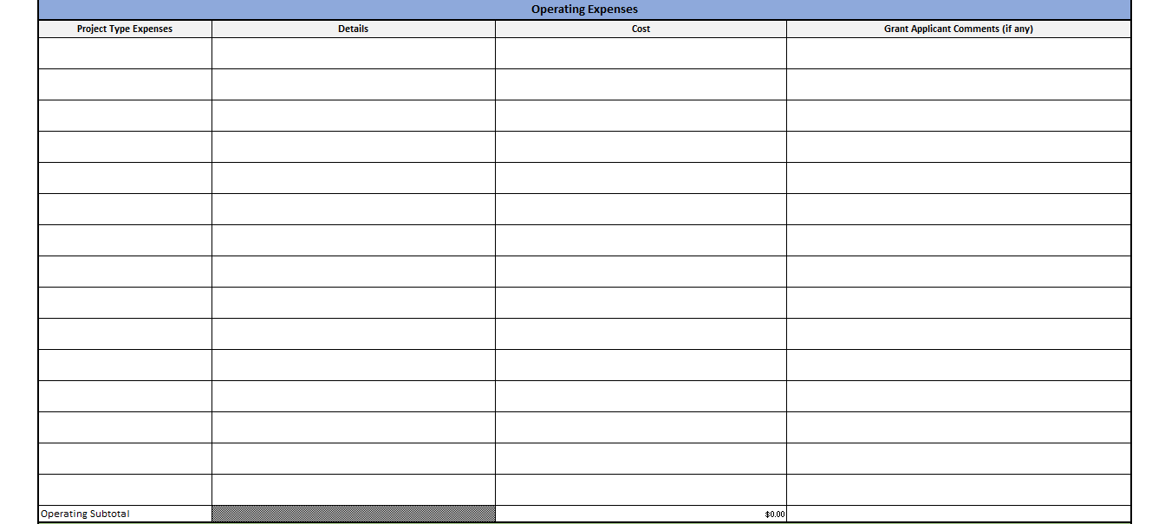
Appendix C - Link to Form: Project Types and Standard Outcome Measures
Project Types and Standard Outcome Measures

The Department of Developmental Services created eight different project types that describe broad categories of projects associated with the grants for enhanced community integration for children and adolescents (social rec. grants). Standard outcome measures have been developed for each project type.

Standard Outcome Measures for All Grant Projects except Vendorization Assistance:
Grantees will be required to report data for the 8-month grant project term. The following standard outcome measures have been developed for all grant projects except Vendorization Assistant, regardless of grant amount.
- Number of individuals that are directly served by the grant project. Do not count an individual or family more than once
- Race or ethnicity of individuals served by the grant project, if known. Individuals may self-identify their race or ethnicity
- Languages spoken and/or written by grantee when providing services funded by the grant project to individuals
- Number of new inclusive social and recreational activities accessed by individuals
- Number of individuals that made at least one new friend, if applicable. A new friend is someone the individual is familiar with and enjoys his/her company during play or other interactions

Approved grant projects at or above $100,000 will also be required to report on supplemental outcome measures associated with the grant project type.
Grants that will provide Vendorization Assistance will report on outcome measures that are unique to this project type, regardless of grant amount.

Project Type: Community Connector
Proposals can include individualized support to families for the purpose of accessing social and recreational programs through community connectors such as community leaders, self-advocates, and/or family members.

Community connector projects include, but are not limited to, those that:
- Create and disseminate resource guides for community, social and recreational programs
- Coordinate with RC staff individualized options to support access to social and recreational programs including on-going communication between the family, the community connector and the regional center
- Create person-centered one-page profiles with individuals to facilitate integration and inclusivity
Supplemental Outcome Measures for Community Connector Projects at or above $100,000:
- Number and name of inclusive social and recreational programs accessed by individuals through the Community Connector
- List of person-centered thinking tools used to facilitate integration and inclusivity
- Examples include, but are not limited to: Person Centered Thinking Planning Skills that were used; One Page Profiles; What’s Working/Not Working; Good Day/Bad Day; Rituals and Routines; Staff Matching; and Positive Reputation
- Other measurable outcomes

Project Type: Community Engagement and Friendship Outreach
Proposals can increase community awareness and engagement through outreach activities that focus on friendship development and inclusion of individuals with all abilities. Community outreach may include individuals and the general population. Community engagement and friendship outreach projects include, but are not limited to, the following:
- Peer-mentorship training programs
- Big Brother/Big Sister programs
- Socialization or social skills training
- Programs that integrate family and/or siblings in social and recreational activities

Supplemental Outcome Measures for Community Engagement and Friendship Outreach Projects at or above $100,000:
- Number of training classes held
- Number of people (include general population and individuals) who attended training
- Number of outreach or community engagement events
- Number of people (include general population and individuals) who attended outreach or community engagement events
- Other measurable outcomes

Project Type: Education and Training
Proposals can include education and training programs for staff, peers and the community about: children and adolescents with I/DD and their physical and behavioral needs; how to support children and adolescents with I/DD in social and recreational programs; and how RCs serve children and adolescents with I/DD. Education and training projects include, but are not limited to, the following:
- Overview of the RC system and types of services and supports provided by the RC
- Impact of developmental disabilities on individuals and their families
- Information about accessing social and recreational programs
- Best practices for direct staff to facilitate and support individuals with I/DD to participate in social and recreational activities
- Peer-mentorship training programs
- Certification programs that focus on supporting people with I/DD and their physical and behavioral needs

Supplemental Outcome Measures for Education and Training Projects at or above $100,000:
- Number of training classes held
- Number of staff that attended and completed training (may include certification)
- It is recommended that training programs include an assessment component and criteria for participants to meet training competencies such as pre-tests and posttests to measure learning. Supporting documentation must be available upon request.
- Number of community members that attended and completed training
- Number of individuals who were served by trained/certified staff
- Other measurable outcomes
Project Type: Financial Assistance
Proposals can provide financial assistance for fees or reduced fees for inclusive social and recreational programs and activities to individuals. Financial assistance projects cannot be income based.
Awarded funds may not be used to pay RC vendored providers for social and recreational services. Financial assistance will be permitted only if funding of the social and recreational program is not available via POS. Financial assistance is not intended for a one-time activity unless the one-time activity compliments or is part of an ongoing or recurring activity. The onetime activity must be described in the grant proposals.

Financial assistance projects could include, but are not limited to, the following:
- Membership or activity scholarships
- Reduced fees for monthly memberships and/or activity fees
- Art classes that include an exhibition featuring art created by class participants

Supplemental Outcome Measures for Financial Assistance Projects at or above $100,000:
- Number of reduced fees and/or scholarships granted to individuals
- Dollar value of reduced fees and/or scholarships granted to individuals
- Other measurable outcomes

Project Type: Increased Access to Programs that are Culturally and Linguistically Sensitive
Proposals can increase capacity for bilingual or multilingual staff and provide information or services in languages represented within the RC’s catchment area. Bilingual or multilingual staff will support children with I/DD for the purpose of integration into social and recreational programs. Translated documents and educational materials will support access to inclusive social and recreational programs. Projects that increase cultural and language access include, but are not limited to, the following:
- Increased staffing that reflects underserved communities
- Salary or stipends for bilingual/multilingual staff. Stipends may include additional pay for existing staff that provide bilingual/multilingual direct support to individuals. Stipends must be new pay that was not available prior to the grant project
- Cultural and linguistic competence training
- Development and review of documents and translation of outreach materials such as registration forms, flyers, web sites and other educational materials in languages that reflect the catchment area

Supplemental Outcome Measures for Increased Accessed to Programs that are Culturally and Linguistically Sensitive Projects at or above $100,000:
- Number of new culturally and linguistically competent staff hired
- Number of stipends paid to bilingual/multilingual existing staff
- Number of staff that completed culturally and linguistic competence training.
- It is recommended that training programs to include an assessment component and criteria for participants to meet training competencies such as pre-tests and post-tests. Supporting documentation must be available upon RC’s request.
- Number of training classes related to culturally and linguistically competence training held
- Number and type of documents and outreach materials translated
- Examples of documents and outreach materials may include but not be limited to
brochures, flyers, registration forms, websites, and other types of educational
information that will be disseminated to the target population
- Other measurable outcomes

Project Type: Setting Modification
Proposals can include setting modifications that enhance and facilitate equal access to recreational settings and interactions between peers with and without I/DD. Proposals that include modifications for the purposes of meeting American Disability Act (ADA) compliance will not be approved. Proposals must include statute, regulations, or documentation to support that it is not an ADA modification. Modifications are not for capital improvements. Setting modification projects include, but are not limited to, the following:
- Standing changing stations
- Wheelchair accessible playground equipment

Supplemental Outcome Measures for Setting Modification Projects at or above $100,000:
- Number of setting modifications completed
- Brief description of progress toward completion of setting modification
- Other measurable outcomes

Project Type: Transportation
Proposals can increase access to inclusive social and recreational programs through transportation. Modifications of vehicle(s) owned by grant applicants must not exceed the value of the vehicle(s).

Transportation projects include, but are not limited to, the following:
- Funding or passes for use of public transportation
- Vehicle modification (e.g., adding a wheelchair lift, van conversion)
- Pick up and drop off service for children and/or adolescents between the family home and a social and recreational program

Supplemental Outcome Measures for Transportation Projects at or above $100,000:
- Number of completed vehicle modifications
- Brief description of progress toward completion of vehicle modification
- Dollar value and number of bus passes provided to individuals
- Dollar value and number of vouchers provided to individuals
- Number of individuals that used pick up and drop off service. Do not count the same individual more than once
- Other measurable outcomes

Project Type: Vendorization Assistance
Proposals can assist social and recreational programs that are not vendored with a RC pursue and obtain vendorization. Vendorization assistant proposals will provide education about vendorization requirements and establish a RCs vendorization process to guide the social and recreational program. The vendorization assistant will have general knowledge of local social and recreational programs for the purpose of assisting the vendor applicant design a program that will provide inclusive and integrated social and recreational program opportunities. The vendorization assistant will have general knowledge of the RC’s restoration of camping, social recreation and other services purchase of service policies. Vendorization assistant projects include, but are not limited to, the following:
- Education about vendorization requirements
- Program design development
- Collaboration facilitation between the RC and the vendor applicant
- Assistance with translating vendor applications and completing forms required for vendorization
- Assistance with contract execution between the RC and vendor applicant

Supplemental Outcome Measures for Vendorization Assistant Projects at or above $100,000:
- Number of social and recreational programs contacted and inquired about vendorization interest with a RC.
- Number of social and recreational programs that declined vendorization interest with a RC.
- Number of social and recreational programs in the vendorization process with a RC.
- Number of social and recreational programs in the program design development process.
- Number of social and recreational programs pending RC application and program design review.
- Number of social and recreational programs vendored with a RC.

Appendix D - Link to Form: Definition of Key Terms
Social Rec Grants Definition of Key Terms

Community Based Organizations (CBO)
For the purposes of this grant, a CBO is defined as a public or private nonprofit, or private for-profit organization that is representative of and advocates for a community or significant segments of a community.
General population
Persons without an intellectual and developmental disability (I/DD) and who are not directly served by a RC.
Goals
Targets established by the grant applicant for standard outcome measures. Reference Project Types and Standard Outcome Measures (Appendix C) for project type descriptions, standard outcome measures, data collection suggestions and examples.
Individuals
Persons served by a regional center who have an I/DD.
One-Page Profile
A one-page profile is a document that informs staff and peers about the child or adolescent with I/DD and how to best support during the program activities. A one-page profile typically captures important information about the person in three headings: what people appreciate about the person, what’s important to the person, and how to best support the person. Consult your RC to discuss how a one-page profile may be created for the child being supported (Resource:http://helensandersonassociates.co.uk/person-centred-practice/one-page-profiles/)
Person Centered Planning (PCP)
PCP helps the person being supported to explore and share what a meaningful life looks like for them and to describe the supports needed to achieve that life. The planning process may include the discovery of various person-centered skills including but not limited to: What is important TO the person’ What is important FOR the person; What supports the person needs to have a good balance between important TO and Important FOR; or Good Day/Bad Day. Consult with the RC Designee to discuss how PCP may be explored. (Resource: https://tlcpcp.com/about-us/)
Project Type
The Department has created seven different project types that describe broad categories of grant projects. Descriptions and examples of project types are described in Project Types and Standard Outcome Measures (Appendix C). Each grant applicant will select one or more of the seven project types that best describe their grant program. Only one Letter of Intent (Appendix A) is required for grant proposals that include one or multiple project types.
Regional Center Designee
The lead person the RC designates to provide oversight and monitoring of the grant project. RC staff that may provide technical assistance to the grantee. See Regional Center Directory (Appendix E) for a list of RC designees.

Regional Centers (RCs)
RCs are private nonprofit corporations that contract with the Department to provide or coordinate services and supports for individuals with I/DD. There are 21 RCs in California. See Map of Regional Center System (Link on page1).
Standard Outcome Measures
Outcome Measures are standard data points used to measure the progress and outcomes of grant projects. Standard outcome measures have been developed for each project type. For more information on outcome measures, see Project Types and Standard Outcome Measures (Appendix C).

Appendix E- Link to Full Directory: Regional Center Directory

