2016 Southern California APSE
Conference & Networking Event

REGISTRATION FORM

First Name: Last Name:

Email Address:

Phone Number: ( ) -

Company/Organization:

Role/Job:

I am a current APSE member (circle): YES NO APSE #:

Additional attendees? (circle) YES NO Number:

Comments/Questions:

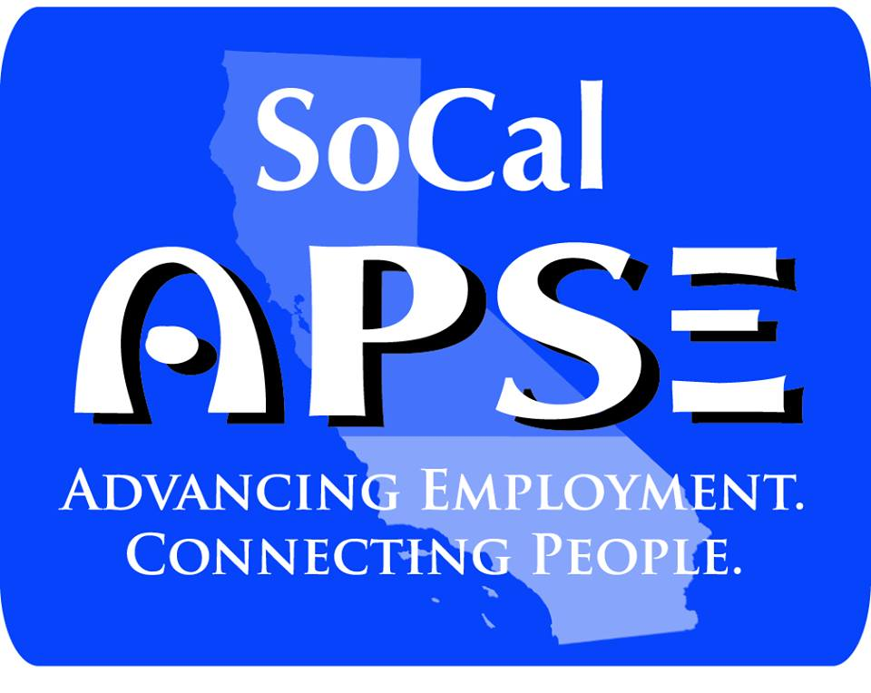
Print this form and mail with check to:

Angela Cooper, CESP
The Campbell Center
6512 San Fernando Rd.
Glendale, CA 91201

Make checks payable to SoCal APSE.
www.SoCalAPSE.org

